Vault Professional Engineering Change Order


OVERVIEW VALUE
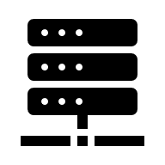
Eﬃcient and accurate change management is crucial for the success of engineering projects. Many companies struggle with errors, delays, and miscommunications due to inadequate change order processes. Autodesk Vault's Engineering Change Order (ECO) capabilities offer a comprehensive solution to these challenges, revolutionizing the way your team handles changes and ensuring that your projects stay on track and within budget
SERVICES & DELIVERABLES

- Session on Vault Change Order
- Change Order Configuration
- Property Mapping for ECO’s
- Numbering Scheme for ECO’s
- Routing Configuration
- User Roles mapping
- Email Notifications


IMPLEMENTATION ROADMAP
Phase | Outcome
1 | Discovery Change Orders
2 | Change Order Configuration
3 | Testing and Validation
4 | User and Administrative training on ECO’s
5 | Remote Go-Live Support

