Vault Professional Items


OVERVIEW VALUE
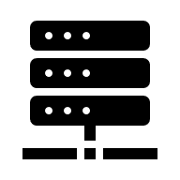
Autodesk Vault Items provide a structured, lifecycle-driven approach to managing product data by introducing a centralized “item master” for parts, assemblies, and bills of materials (BOMs). Within Autodesk Vault, items enable controlled revision management, streamlined change processes, and accurate BOM control, independent of CAD files. The result is reduced rework, improved data consistency, and faster, more reliable decision-making across engineering and manufacturing teams.
SERVICES & DELIVERABLES

- Discovery Session on Vault Items
- Configuration of Vault Items
- Lifecycles for Items
- Revision for Items
- Categories for Items
- Properties Mappings for Items
- Numbering Scheme for Items


IMPLEMENTATION ROADMAP
Phase | Outcome
1 | Discovery Vault Items
2 | Vault Items Configuration
3 | Testing and Validation Vault Items
4 | User and Administrative training on Vault Items
5 | Remote Go-Live Support

